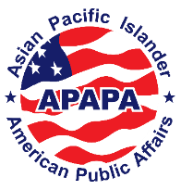

Asian Pacific Islander American Public Affairs
Community Education Foundation
Advancing Leadership and Civic Engagement

APAPA
Chapter Address
501(c)(3) Tax ID # 55-0849384
Chapter Email or Phone Number

To: First Name, Last Name
Job Title
Organization Name
Address
City, State, Zip Code

RE: APAPA’s Chapter Name – Event Name
Event Date | Venue | Venue Address

Dear Full Name,

The Asian Pacific Islander American Public Affairs Association (APAPA) is a nonpartisan, 501(c)(3) nonprofit founded in 2001 with a mission of advancing Asian American and Native Hawaiian/Pacific Islander (AANHPI) Communities through increased leadership and civic engagement.

We are reaching out to see if you are interested in sponsoring our Chapter Name. We are having an Event Name on Event Date at Venue in City.

The funds raised go toward supporting our Chapter Name. Our APAPA chapters are volunteer-driven and serve our communities throughout the country by leading forums, town halls, a national internship program, professional development workshops, and networking events designed specifically for the betterment and advancement of the AANHPI community. Sponsorship information is attached.

Please let me know if you are interested and if you have any questions.

We appreciate your support and sincerely hope that you will accept our invitation to participate in this special event.

Sincerely,
Name

